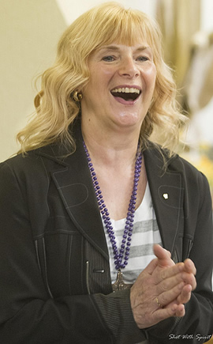**St Joseph’s Prayer Centre**

**Weekend September 20th – 22nd 2024**

**‘Born for Such a Time as This’**

A Retreat with Ros Powell (www.rospowell.com)

Come, and be ‘blessed and filled’ to be a blessing to others

as you take time with God in beautiful settings

to be ‘Equipped and Empowered’

for the times we are living in,

and the days ahead

The weekend will include:

Bible teaching and encouragement - Personal faith stories

Breakout groups (Proverbs27:17 “As iron sharpens iron, so

one person sharpens another”)

‘Equipping and empowering’ to use to use the gifts of the

Holy Spirit for yourself and others

Free time - Praying together - Healing Service - Adoration

Residential £180pp includes meals

Non-residential £120pp Includes meals

Holy Mass will be available each day including Mass of Healing on Saturday at 7pm all welcome.

Registration from 3pm on Friday 20th September

Conference begins after supper on Friday at 7.15pm and will finish after lunch on Sunday.

Book by Telephone 01704875850 or Email:theprayercentre.stj@psmgs.org.uk

£50 deposit is needed to confirm booking

St Joseph Prayer Centre, Blundell Avenue, Formby, Liverpool L37 1PH

There will be a collection during the weekend for Ros Powell’s ministry

Ros asks that each participant brings their personal bible